The purpose of the Storybook Quick-Start Guides is to help you (the developer) to get up to speed with Storybook as quickly as possible. We will do that by providing the absolute minimum information that you will need to effectively use Storybook to develop a UI component.
In this document, we focus on common development workflows:
1. Confirm that the correct Node.js version is installed.
2. Pull (retrieve) the starter project from GitHub.
3. Make sure that Storybook is up to date.
4. Start and stop Storybook.
5. Initialize ShadCN
6. Install a ShadCN atom component in Storybook Next.js
7. Testing a ShadCN atom component’s compatibility in Storybook
8. Install a ShadCN molecule component in Storybook Next.js
9. Testing a ShadCN molecule component’s compatibility in Storybook
10. Building a complex atomic component in Storybook Next.js
11. Building a complex molecule component in Storybook Next.js
12. Your complex atomic component as a Storybook story
13. Building a complex molecule component as a story in Storybook
----------------------------------------------------------------------------------------------------------
1. Confirm that the correct Node.js version is installed.

In a VSCode terminal,
Enter this command:
node –version

and you should see v18.17 or later

If node is not up to date – download the latest node package at:
https://nodejs.org/en/download

----------------------------------------------------------------------------------------------------------
2. Pull (retrieve) the starter project from GitHub
You will do all of your Storybook development work in a simple starter app that we have prepared for you. This app is a Next.js starter app with Tailwind, ESLint, Typescript, and Storybook installed.

To retrieve the starter app from GitHub,
Run these commands in a terminal;
git clone https://github.com/RHowland/shadcn-sbook-app01
npm install

Confirm that the starter app is working properly:
Enter this command:
npm run dev

and you should see something similar to this in your terminal output;

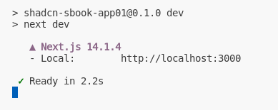

To view the app, in a web browser,
Enter this URL:
http://localhost:3000

and you should see this web page:
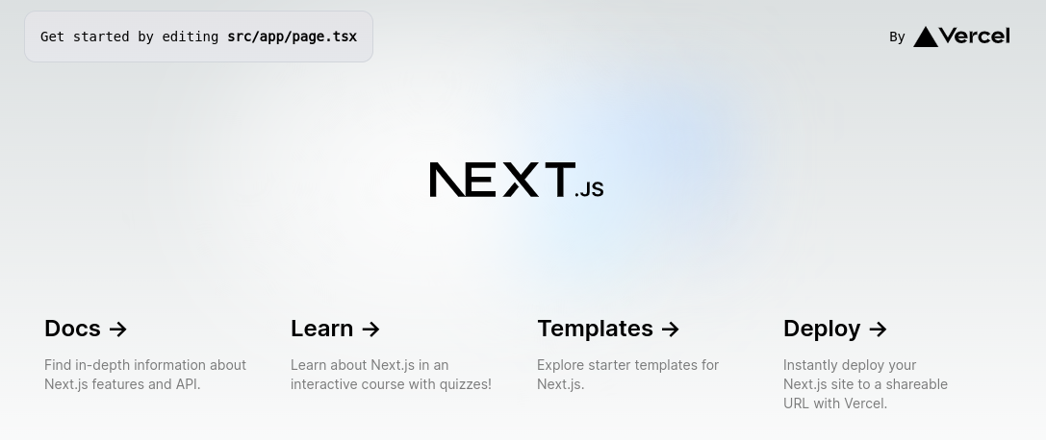
To stop the Dev Server, in a terminal,
Enter:
CTRL-C

and the terminal prompt will re-appear.

----------------------------------------------------------------------------------------------------------
3. Make sure that Storybook is up to date.
To confirm that the latest version of Storybook is installed:
Enter:
npx storybook@latest upgrade

If you see the following error – storybook is up to date;

If you see the following prompt (Need to install the following packages) in terminal – storybook needs to be updated along with an auto-migration;

Answer y (yes) to all prompts asked during the upgrade.

For a more complete guide on upgrading storybook – please follow the storybook upgrade guide

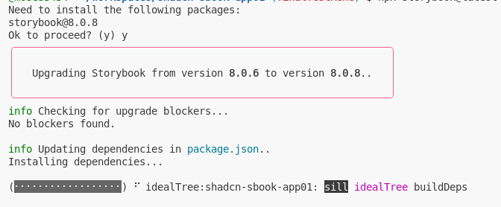

----------------------------------------------------------------------------------------------------------
4. Start and Stop Storybook.

Start Storybook
There are two steps to starting Storybook
- start the Storybook Server
- start the Storybook UI
The Storybook server is the invisible part of Storybook that runs behind the scenes and provides the interactive functionality that makes Storybook so powerful.
The Storybook Interface is the visible part of Storybook in which you can view and interact with UI components, in isolation.

When you start the Storybook Server, and it becomes operational, it will attempt to open a web browser at this url: “http://localhost:6006”. If the Storybook UI does not automatically appear in the web browser, you will have to manually enter this URL in the web browser.
To start the Storybook Server,
in VSCode,
in a terminal,
Enter this command:
npm run storybook

and in the terminal,
you should see something similar to the following output:

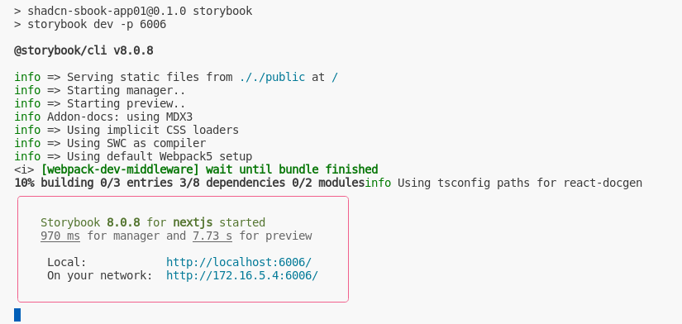
At this point, you should see a tab panel open up in your web browser, and the Storybook UI should appear in that tab. If this does not happen automatically, you may need to enter the following URL in the web browser:
http://localhost:6006/

When the Storybook UI is visible, it should appear similar to this next screen image except that your left panel will probably be different.

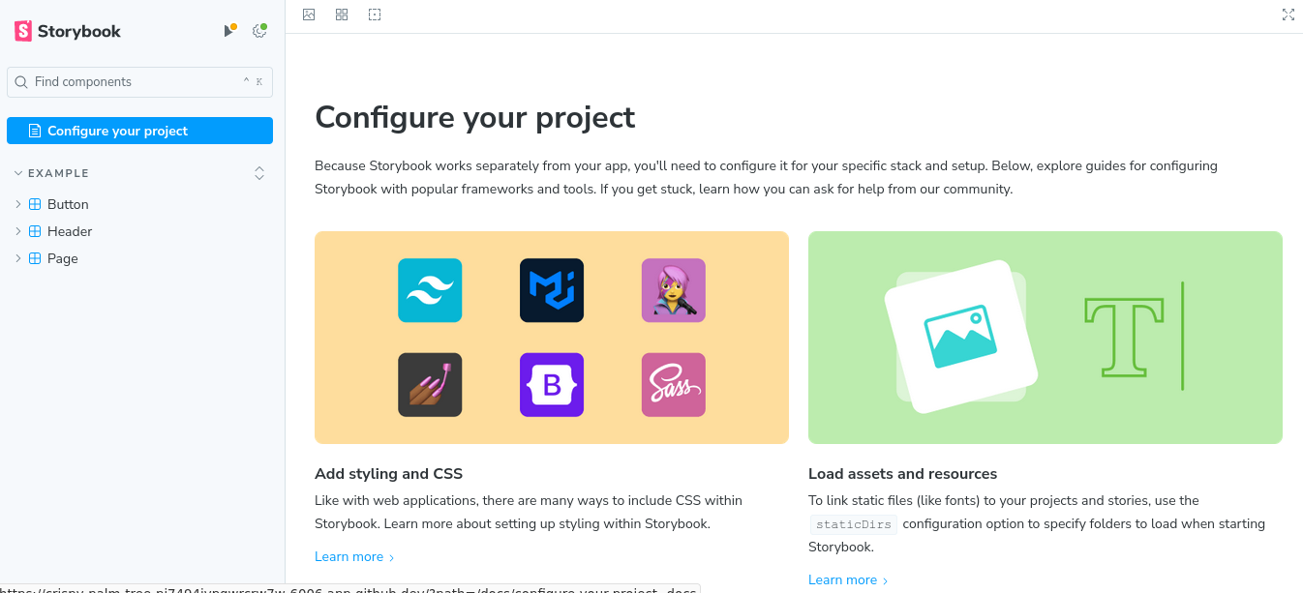
In the previous screen image, the Storybook UI will show you these items:
- The Sidebar (on the left)
- sample components (referred to as “Stories”)
- the canvas (the large white panel to the right)
- in this view, the canvas contains links to additional Storybook help.
This is also where a UI component will appear when it is in interactive mode.
At this point, you have successfully started Storybook.

Stop Storybook

------------------------------------------------------------------------------------------------------------

5. Initialize ShadCN

ShadCN is a copy-and-paste web component repository to help you build component libraries and is built on top of Radix-ui. It will help you import your components more efficiently for eventual use in Storybook by automating both the dependency configurations for Radix-ui and copy and pasting the code into your project for you.

In a VSCode terminal,
Enter this command:
npx shadcn-ui@latest init

and you should be prompted the following json configuration questions in your terminal output;

Which style would you like to use? › Default
Which color would you like to use as base color? › Slate
Do you want to use CSS variables for colors? › yes

Answer Default, Slate, and yes as indicated above.

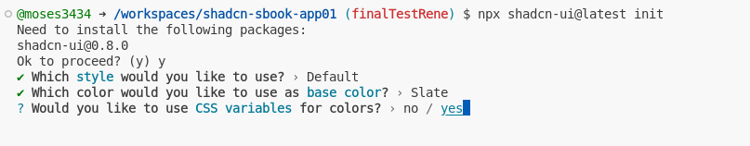

At this point, your app directory structure should be as follows for your ‘src’ folder and your terminal should show the following result;

src --
-- app
-- components
-- lib
-- stories

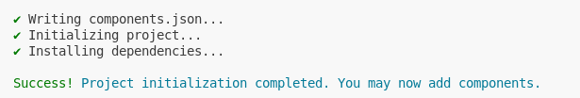
-----------------------------------------------------------------------------------------------------------

6. Install a ShadCN atom component

To install a ShadCN component browse to ‘https://ui.shadcn.com/https://ui.shadcn.com/docs/components/[component-you-would-like-to-import]’

For our example we will be importing a label component. Please review appendix B for additional examples

Browse to ‘https://ui.shadcn.com/https://ui.shadcn.com/docs/components/label’

Scroll down to installation as shown below and run the npx command as shown;

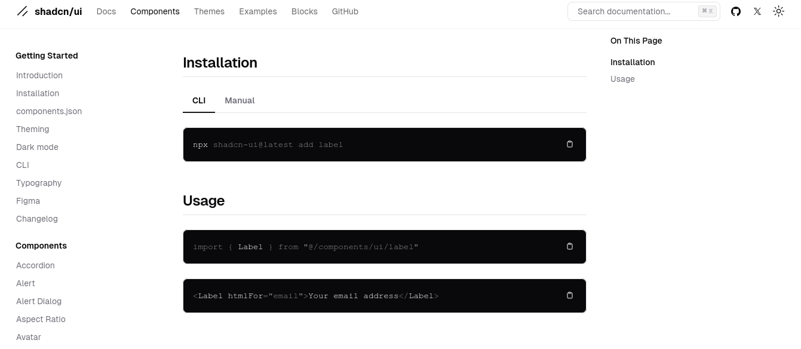
Enter:
npx shadcn-ui@latest add label

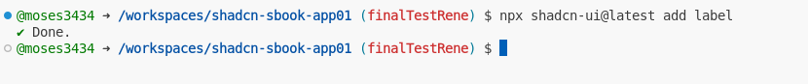
At this point, you should see the label.tsx file in your directory structure as shown below;

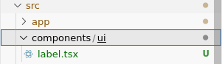

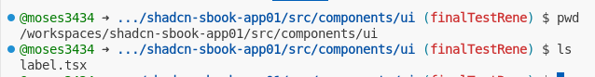
Congratulations, you have imported your first ShadCN component

-------------------------------------------------------------------------------------------------------------

7. Testing your ShadCN atom component’s compatibility in Storybook

Note: There are two steps involved here – both steps can be found at https://ui.shadcn.com/docs/components/[your-component-here] (in our case example our component is ‘label’) under ‘USAGE’ ,found just below the components installation instruction as shown in the image below;

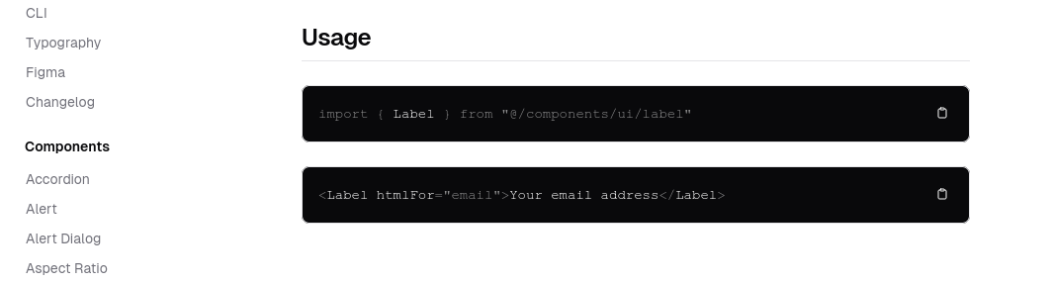

Open your Configure.mdx file located at src/stories/;
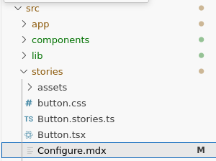

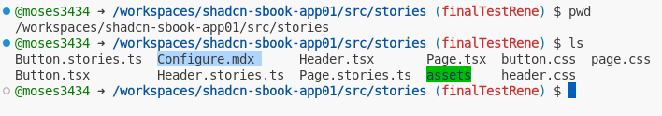

Import your shadCN component you installed in the previous section into your Configure.mdx file;

Enter;

import { Label } from "@/components/ui/label"

as shown;
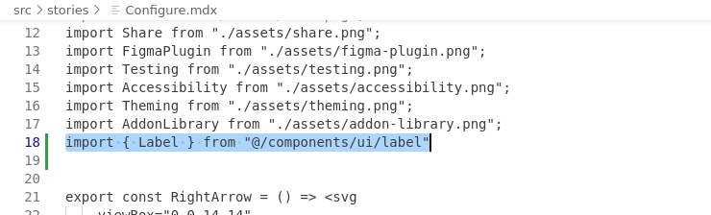

Secondly, enter the appropriate component HTML into your Configure.mdx file – which in our case is the label component;

<Label htmlFor="email">Your email address</Label>

as shown by;

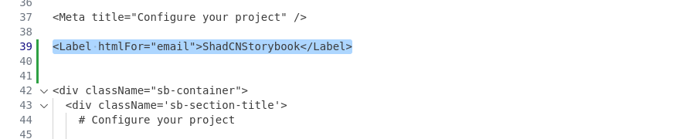

Now head back to your root in your app

Enter;

npm run storybook

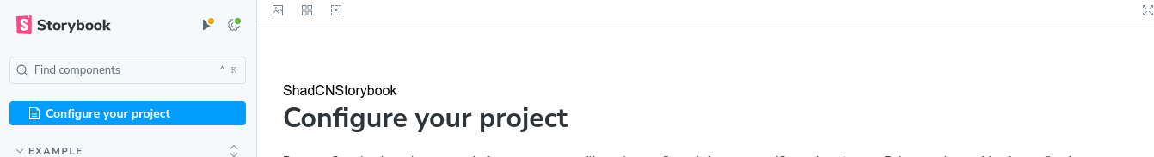

At this point, your storybook you should now see your component rendered. In our case our label component here rendered above ‘Configure your project’ as ‘ShadCNStorybook’.

We can now confirm that the ShadCN component is compatible with our storybook Next.js app

--------------------------------------------------------------------------------------------------------------

8. Installing a ShadCN molecule component

To import a ShadCN component browse to ‘https://ui.shadcn.com/https://ui.shadcn.com/docs/components/[component-you-would-like-to-import]’

For our example we will be importing a card component. Please review appendix B for additional examples

Browse to ‘https://ui.shadcn.com/https://ui.shadcn.com/docs/components/card’

Scroll down to installation as shown below and run the npx command as shown;

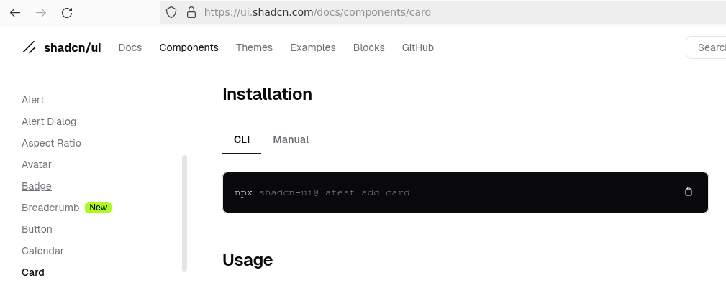

Enter:
npx shadcn-ui@latest add card

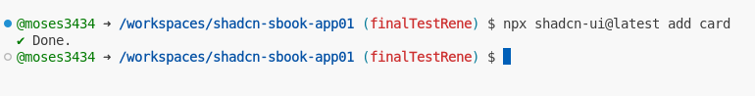
At this point, you should see the card.tsx file in your directory structure as shown below;
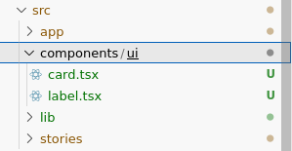

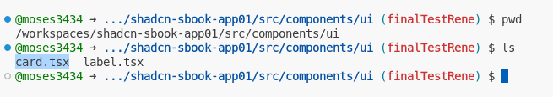
Congratulations, you have imported your first ShadCN molecule component
---------------------------------------------------------------------------------------------------------------

9. Testing a ShadCN molecule component’s compatibility in Storybook

Note: There are two steps involved here – both steps can be found at https://ui.shadcn.com/docs/components/[your-component-here] (in our case example our component is ‘card’) under ‘USAGE’ ,found just below the components installation instruction as shown in the image below;

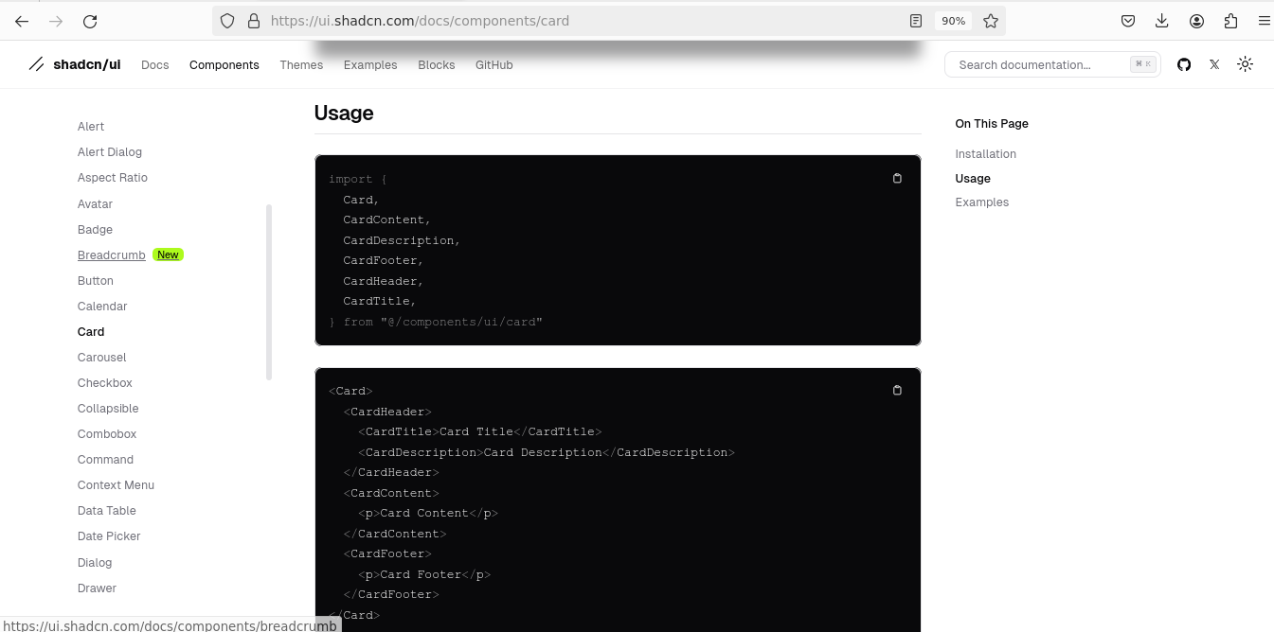

Open your Configure.mdx file located at src/stories/;

Import your shadCN component you installed in the previous section into your Configure.mdx file;

Enter;

import {
Card,
CardContent,
CardDescription,
CardFooter,
CardHeader,
CardTitle,
} from "@/components/ui/card"

as shown;

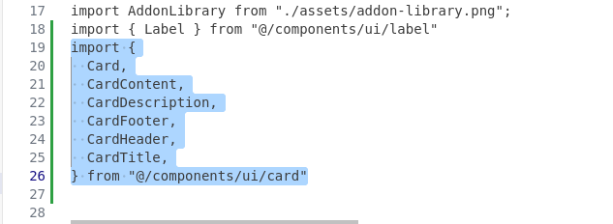
Secondly, enter the appropriate component HTML into your Configure.mdx file – which in our case is the card component;
<Card>
<CardHeader>
<CardTitle>Card Title</CardTitle>
<CardDescription>Card Description</CardDescription>
</CardHeader>
<CardContent>
<p>Card Content</p>
</CardContent>
<CardFooter>
<p>Card Footer</p>
</CardFooter>
</Card>

as shown by;

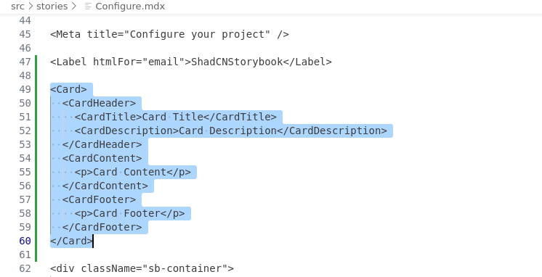
Now head back to your root in your app

Enter;

npm run storybook

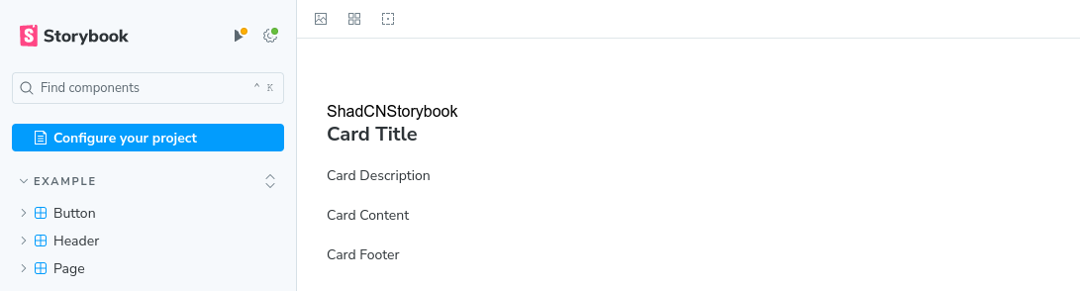

At this point, in your storybook you should now see your component rendered. In our case our label component here rendered below ‘ShadCNStorybook’ as ‘Card Title’.

We can now confirm that the ShadCN component is compatible with our storybook Next.js app

------------------------------------------------------------------------------------------------------------------

These are the usual steps to follow when maintaining an existing component:
1. xxxx xxxxxx xxxxxx
2. xxxxxxxxxxx xxxx xx
3. xxxxx xxxxxxxx xx

Here some additional workflows that may be needed from time to time:
1. xxxx xxxxxx xxxxxx
2. xxxxxxxxxxx xxxx xx
3. xxxxx xxxxxxxx xx

(Please use the Courier New 12 pt bold font for all code lines)

(End of Document)

